Independent Engineering Project
DESIGN AND SIMULATION OF A SOLAR-BATTERY
MICROGRID FOR A RURAL HEALTH CENTER IN RWANDA
A self-initiated project designed to explore a practical, low-cost
power solution for rural health facilities in Rwanda
Hussein NSANZIMFURA
Electrical Power Engineer
Kigali, Rwanda
2026

Abstract
Many rural health centers in Rwanda struggle with unreliable electricity. Some are not connected to the national grid, while others depend on diesel generators that are costly to run and frequently out of service. Yet these facilities operate critical equipment such as vaccine refrigerators, laboratory devices and lighting for maternity care, which cannot tolerate power interruptions. This project, undertaken independently, designs and simulates a standalone solar-battery microgrid capable of supplying a typical rural health center reliably throughout the year.
The daily electricity demand of the facility was assessed at approximately 21.3 kWh, and a design load of 20 kWh per day was adopted. Solar resource data for a site near Nyagatare was obtained from PVGIS using 19 years of records (2005-2023), giving a worst-month value of 4.06 peak sun hours per day, which was used as the sizing basis to guarantee year-round reliability. The resulting system comprises a 7 kWp solar array, a 40 kWh lithium (LiFePO4) battery bank, a 6 kW inverter and a 48 V DC bus.
An hourly energy-balance simulation, implemented in Python, confirmed that the system meets the facility's load for every hour of the day, with zero unmet demand and a minimum battery state of charge of 12.3 kWh. An economic analysis produced a levelized cost of energy of USD 0.364 per kWh for the solar-battery system, compared with USD 0.727 per kWh for an equivalent diesel generator, representing savings of roughly USD 70,600 over a 25-year lifetime. The results show that solar-battery microgrids are a technically sound and economically attractive solution for electrifying rural health facilities in Rwanda.

Chapter 1: Introduction

1.1 Background
This project was undertaken independently, out of a personal interest in using engineering to solve real problems facing rural communities in Rwanda. Access to reliable electricity is one of the foundations of quality healthcare. In Rwanda, considerable progress has been made in expanding the national grid, but many rural health centers remain in areas where the grid is either absent, unreliable, or expensive to extend. In these facilities, electricity is essential for storing vaccines and medicines at safe temperatures, powering diagnostic equipment, lighting delivery rooms at night, and charging communication devices used to coordinate referrals and emergencies.
Where grid power is unavailable, health centers often rely on diesel generators. While generators can provide power on demand, they suffer from high fuel costs, frequent breakdowns, noise, air pollution, and dependence on fuel supply chains that are difficult to maintain in remote districts. As a result, essential services are regularly interrupted, putting patient care and the cold chain at risk.
Solar energy offers a compelling alternative. Rwanda enjoys good and fairly stable solar resources throughout the year, and the falling cost of solar panels and lithium batteries has made standalone solar-battery systems increasingly viable. A well-designed microgrid can supply a health center silently, cleanly, and reliably, with low running costs once installed.

1.2 Problem Statement
Rural health centers in Rwanda require a continuous and dependable electricity supply, yet many lack access to reliable grid power and depend on costly, unreliable diesel generators. There is a need for a clean, affordable and reliable power solution that can be sized appropriately for the real energy demand of these facilities and proven to perform under local solar conditions.

1.3 Objectives
The main objective of this project is to design and simulate a solar-battery microgrid capable of reliably supplying a typical rural health center in Rwanda. The specific objectives are: to assess the daily electricity demand of a representative rural health center; to obtain and analyze solar resource data for the chosen site; to size the solar array, battery bank and inverter using standard engineering methods; to simulate the system's performance over a full day and confirm its reliability; and to evaluate the economic feasibility of the system in comparison with a diesel generator.

1.4 Scope
This project focuses on the electrical design and simulation of a standalone (off-grid) solar-battery microgrid for a single rural health center. It covers load assessment, solar resource assessment, component sizing, an hourly energy-balance simulation, and an economic analysis. Detailed mechanical mounting design, grid interconnection, and full protection-coordination studies are beyond the scope of this work, though key protection and safety considerations are noted.

Chapter 2: Literature Review
Solar-battery microgrids have been widely studied and deployed as a solution for electrifying facilities that are remote from reliable grid infrastructure. The general architecture consists of a photovoltaic array that converts sunlight into electricity, a battery bank that stores energy for use at night and during cloudy periods, an inverter that converts stored DC power into the AC power used by most appliances, and a charge controller or hybrid inverter that manages the flow of energy between these components.
A recurring theme in the literature on health-facility electrification is the importance of reliability. Health centers run critical loads, most notably the vaccine cold chain, that must never lose power. For this reason, standalone systems for health facilities are commonly sized using worst-case solar conditions and include one or more days of battery autonomy, rather than being sized only for average conditions. This conservative approach trades a slightly larger and more expensive system for a far more dependable one.
The choice of battery technology has shifted in recent years. Traditional lead-acid batteries are cheaper to purchase but can only be discharged to about half their capacity without shortening their life, and they typically last only three to five years. Lithium iron phosphate (LiFePO4) batteries, although more expensive upfront, can be discharged more deeply, last around ten years, and require less maintenance, making them increasingly the preferred choice for solar installations in demanding applications.
Economic studies of off-grid power consistently compare solar-battery systems against diesel generators using the levelized cost of energy, which spreads all costs over the total energy delivered during the system's lifetime. Although diesel generators are cheaper to buy, their high and volatile fuel costs usually make them far more expensive over time. This project applies the same widely accepted methods, using Rwanda-specific data, to a representative rural health center.

Chapter 3: Methodology

3.1 Overview of the Approach
The microgrid was designed and tested in five stages: assessing the health center's electricity demand, collecting solar resource data for the site, sizing the system components, simulating the system's performance over a full day, and analyzing its economic feasibility. Each stage fed into the next, so that the final design rests on real data and standard engineering methods rather than assumptions alone.

3.2 Study Area and Facility
The design targets a typical rural health center in Rwanda, located near Nyagatare in the Eastern Province (coordinates 1.589 degrees South, 29.657 degrees East, elevation 1,673 m). This type of facility was chosen because many rural health centers in Rwanda either lack a reliable grid connection or depend on diesel generators, yet they operate critical loads such as vaccine refrigerators that cannot tolerate power cuts. The facility's electricity needs were based on the equipment commonly found in a health center of this size, following Rwanda Ministry of Health and World Health Organization guidelines on health-facility electrification.

3.3 Load Assessment
The daily electricity demand was estimated by listing every electrical appliance in the facility together with its power rating, quantity, and typical hours of use per day. The energy used by each appliance was calculated using the relation:
Energy (Wh/day) = Power (W) x Quantity x Hours per day
The individual figures were summed and converted to kilowatt-hours to give the total daily energy demand. A design margin of 20% was then added to allow for future expansion and system losses, giving a design load of approximately 20 kWh per day. The demand was also distributed across the 24 hours of the day to produce an hourly load profile, showing low demand at night and higher demand during working hours.

3.4 Solar Resource Assessment
Solar irradiation data for the site was obtained from PVGIS (Photovoltaic Geographical Information System), a free tool provided by the European Commission's Joint Research Centre. Monthly irradiation values on a plane tilted at 15 degrees were collected for the years 2005 to 2023. These were averaged for each month and converted to daily peak sun hours. The worst-performing month (November, 4.06 kWh/m2 per day) was used as the basis for sizing, so that the system remains reliable even during the cloudiest part of the year. The yearly average was 4.73 kWh/m2 per day.

3.5 System Sizing
The components were sized using standard off-grid design formulas. The solar array was sized from the design load, the worst-month peak sun hours, and a performance ratio of 0.75, which accounts for real-world losses such as dust, heat and wiring:
PV size (kWp) = Daily energy / (Peak sun hours x Performance ratio)
The battery bank was sized to provide 1.5 days of autonomy, using lithium (LiFePO4) chemistry with an 80% usable depth of discharge and 95% round-trip efficiency:
Battery (kWh) = (Daily load x Days of autonomy) / (Depth of discharge x Efficiency)
The inverter was sized from the facility's peak power demand with a 1.25 safety factor to handle motor start-up surges. A 48 V DC system voltage was selected to keep currents and cable losses low.

3.6 Simulation
The system's performance was simulated in Python using the Google Colab environment. An hourly energy-balance model was built: for each hour, solar generation was compared against the load. When solar exceeded demand, the surplus charged the battery; when it fell short, the battery discharged to cover the load. The battery's state of charge was tracked across all 24 hours, and any unmet load was recorded, making it possible to confirm whether the system could supply the facility continuously.

3.7 Economic Analysis
Finally, the economic feasibility was assessed. The total capital cost was estimated from typical installed prices in Rwanda. The levelized cost of energy, that is the cost per kilowatt-hour over the system's 25-year life including battery replacements and maintenance, was calculated and compared against the cost of supplying the same energy with a diesel generator over the same period.

Chapter 4: System Design and Results

4.1 Daily Load Profile
The load assessment produced a total daily demand of 21.3 kWh with a peak demand of 1.4 kW. The hourly load profile in Figure 4.1 shows a low, steady base load overnight (security lighting, refrigeration and communications), rising through the morning as the facility becomes active, remaining high through midday, and tapering off in the evening.
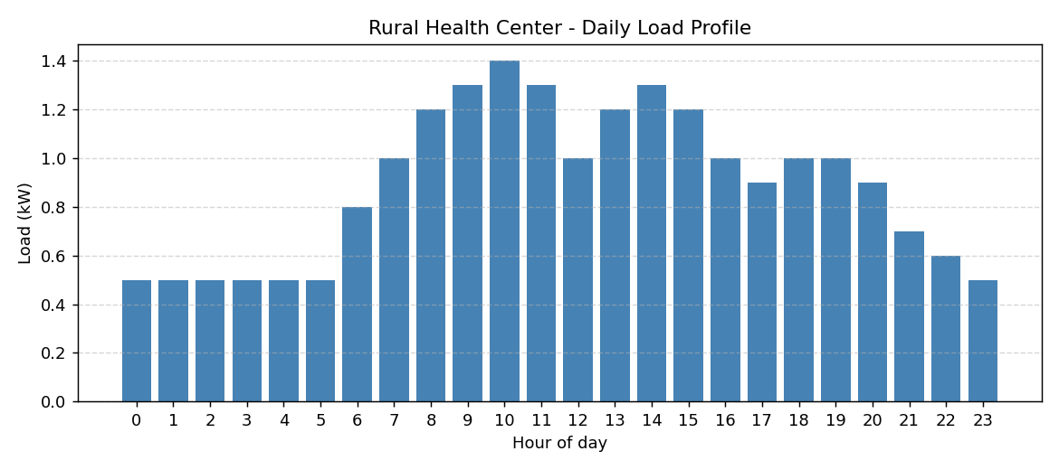
Figure 4.1: Daily load profile of the rural health center.

4.2 Component Sizing Results
Applying the sizing formulas to the design load of 20 kWh per day and the worst-month solar resource of 4.06 peak sun hours gave the final system specification summarized in Table 4.1.

Component | Specification | Basis
Design daily load | 20 kWh/day | 21.3 kWh assessed + 20% margin
Solar array | 7 kWp (13 x 550 W panels) | Worst-month PSH 4.06, PR 0.75
Battery bank | 40 kWh lithium (LiFePO4) | 1.5 days autonomy, 80% DoD
Inverter | 6 kW hybrid | 5 kW peak x 1.25 safety factor
System voltage | 48 V DC | Lower current and cable losses
Table 4.1: Final microgrid design specification.

4.3 Solar Generation versus Load
Figure 4.2 compares the modelled solar generation against the facility load over 24 hours. The solar output follows the expected bell-shaped curve, exceeding demand around midday and falling to zero at night. This illustrates the central challenge of solar supply: generation peaks in the middle of the day, while the facility also requires power in the evening and overnight. The role of the battery is to bridge this gap.
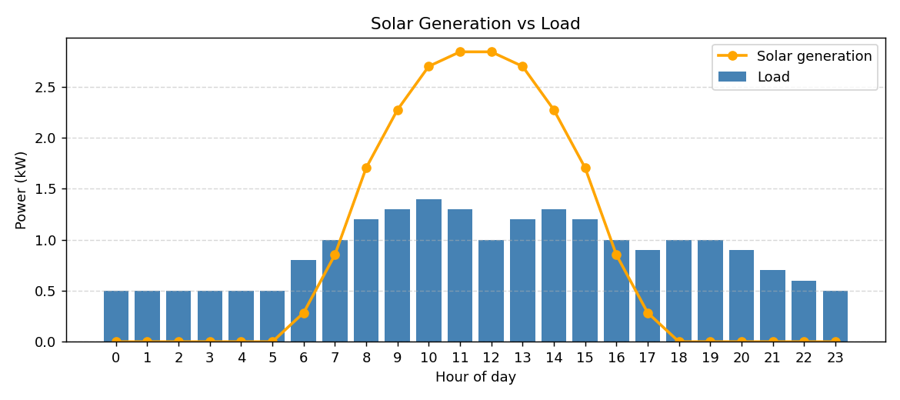
Figure 4.2: Modelled solar generation compared with the daily load.

Chapter 5: Simulation Results and Discussion

5.1 Battery State of Charge
The hourly energy-balance simulation tracked the battery state of charge throughout the day, shown in Figure 5.1. Starting from a half-charged state, the battery discharges overnight to supply the base load, reaching its lowest point of 12.3 kWh in the early morning just before sunrise. As solar generation builds through the morning, the surplus recharges the battery, which reaches its peak in the late afternoon before the cycle repeats.
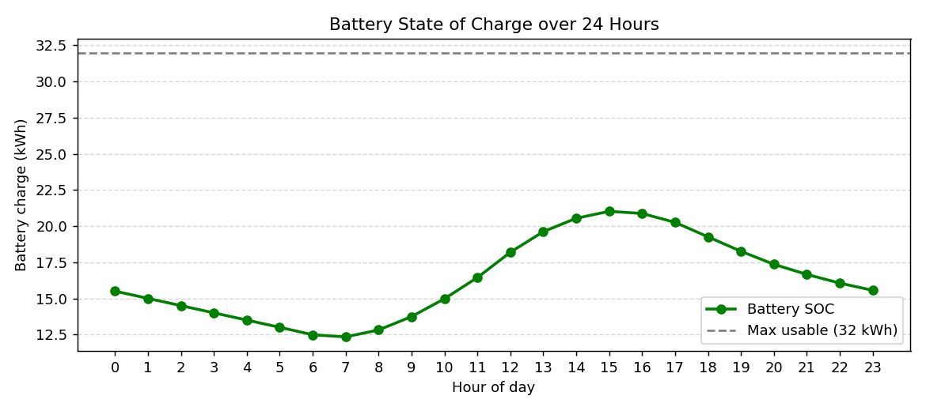
Figure 5.1: Battery state of charge over 24 hours.

5.2 System Reliability
The key reliability result is that the total unmet load over the day was zero: the system supplied the facility for every hour without interruption. The minimum state of charge of 12.3 kWh, well above the empty level, shows that the battery retains a comfortable safety margin even under the worst-month solar conditions used for sizing. This confirms that the design meets the essential requirement of uninterrupted power for a health center.

5.3 Combined Performance
Figure 5.2 brings the load, solar generation and battery state of charge together on a single chart, giving an overall picture of how the system operates as an integrated whole over the course of a day.
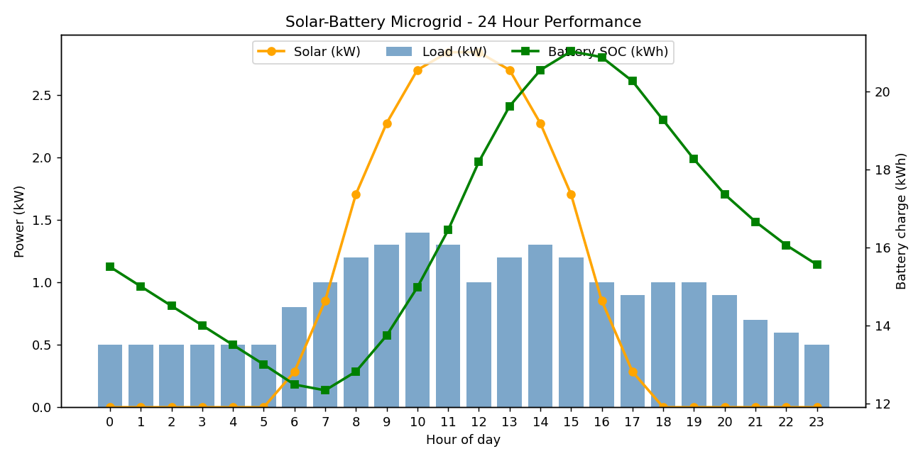
Figure 5.2: Combined 24-hour performance of the solar-battery microgrid.

Chapter 6: Economic Analysis

6.1 Capital Cost
The total capital cost of the system was estimated using typical installed prices for Rwanda, as shown in Table 6.1. The battery bank represents the largest single cost, at roughly 62% of the total, which is normal for solar-battery systems that require substantial storage for reliability.

Item | Cost (USD)
Solar array (7 kWp) | 6,300
Battery bank (40 kWh lithium) | 16,000
Inverter (6 kW) | 1,500
Balance of system (wiring, protection, labour) | 2,000
Total capital cost | 25,800
Table 6.1: Estimated capital cost of the system.

6.2 Levelized Cost of Energy
The levelized cost of energy was calculated over a 25-year project life, including two battery replacements (as lithium batteries last about ten years) and annual operation and maintenance costs of 2% of the capital cost. Over its lifetime the system delivers approximately 194,000 kWh of energy at a total cost of about USD 70,700, giving a levelized cost of energy of USD 0.364 per kWh.

6.3 Comparison with a Diesel Generator
For comparison, the cost of supplying the same energy with a diesel generator over 25 years was estimated, including generator replacements every five years, fuel, and maintenance. The results are summarized in Table 6.2 and Figure 6.1. Fuel dominates the diesel cost and makes the generator far more expensive over time.

Metric | Solar-Battery | Diesel Generator
Lifetime cost (25 yr) | USD 70,700 | USD 141,343
Levelized cost of energy | USD 0.364/kWh | USD 0.727/kWh
Table 6.2: Lifetime cost comparison over 25 years.
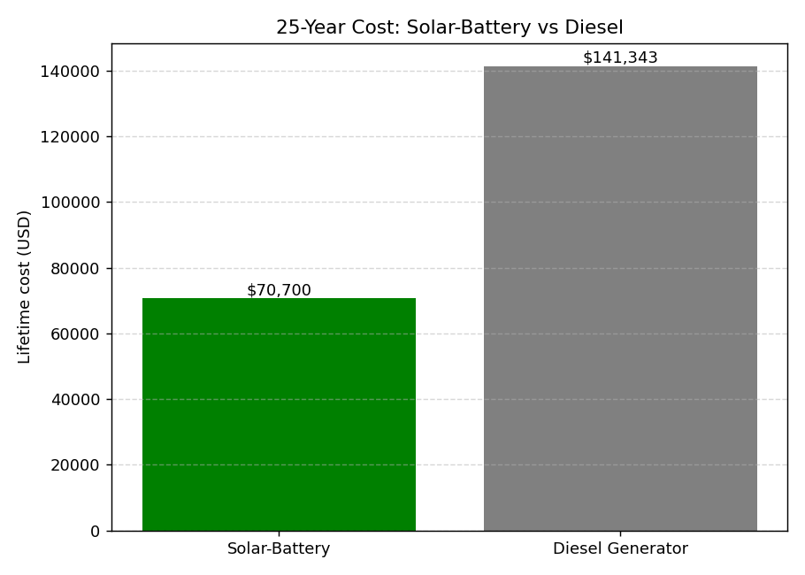
Figure 6.1: 25-year lifetime cost, solar-battery versus diesel.
The solar-battery system delivers electricity at roughly half the cost per unit of a diesel generator and saves approximately USD 70,600 over 25 years. Beyond the direct savings, it also offers silent, clean and dependable operation, which diesel cannot match and which a vaccine cold chain depends upon.

Chapter 7: Discussion
The results confirm that a solar-battery microgrid can reliably and affordably power a rural health center in Rwanda. Sizing the system against the worst solar month, rather than the annual average, is a deliberate design decision that ensures the facility keeps running during the cloudiest period of the year, at the cost of a modestly larger system. For a health center, where the cold chain and emergency care cannot be interrupted, this trade-off is well justified.
Several practical challenges must be considered for a real deployment. Dust accumulation on panels reduces output, so periodic cleaning is needed; the performance ratio of 0.75 used in this design already allows for some soiling. Security is a genuine concern in remote locations, and panels and batteries should be physically protected against theft. Maintenance capacity is also important: lithium batteries and modern inverters require little routine maintenance, but local technicians should be trained to handle faults and replacements. Finally, the load may grow over time as the facility expands, which the 20% design margin partly anticipates.
The economic analysis depends on assumed prices, particularly for batteries and diesel fuel. Battery prices have been falling, which would improve the solar case further, while any rise in fuel prices would make diesel even less attractive. The overall conclusion, that solar-battery supply is substantially cheaper than diesel over the system's life, is robust to reasonable variation in these assumptions.

Chapter 8: Conclusion and Recommendations

8.1 Conclusion
This project designed and simulated a standalone solar-battery microgrid for a typical rural health center in Rwanda. Based on an assessed daily demand of 21.3 kWh and real solar data for a site near Nyagatare, the final design comprises a 7 kWp solar array, a 40 kWh lithium battery bank, a 6 kW inverter and a 48 V DC bus. An hourly simulation confirmed that the system supplies the facility with zero unmet load and a healthy battery margin even under worst-month conditions. Economically, the system delivers energy at USD 0.364 per kWh, about half the cost of a diesel generator, saving roughly USD 70,600 over 25 years. The project demonstrates that solar-battery microgrids are both a technically sound and an economically attractive way to electrify rural health facilities in Rwanda.

8.2 Recommendations
For real-world implementation, it is recommended that a detailed on-site load survey be carried out at the specific target facility to refine the design, and that the system include remote monitoring so that performance and battery health can be tracked and faults detected early. Local technicians should be trained in basic operation and maintenance, and physical security measures should be included to protect the equipment. Future work could extend the model to simulate a full year of operation using hourly weather data, investigate the benefits of connecting several nearby facilities into a shared microgrid, and add smart load management to prioritize critical equipment during extended cloudy periods.

References
[1] European Commission, Joint Research Centre. Photovoltaic Geographical Information System (PVGIS). Available at: re.jrc.ec.europa.eu.
[2] World Health Organization. Guidelines and standards for the electrification of health facilities.
[3] Republic of Rwanda, Ministry of Health / Rwanda Biomedical Centre. Standard equipment lists for health centers.
[4] International Renewable Energy Agency (IRENA). Off-grid renewable energy solutions and cost trends.
[5] Rwanda Energy Group (REG). Rwanda energy sector and rural electrification data.

